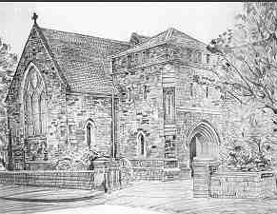
SAINT JOHN’S MALONE

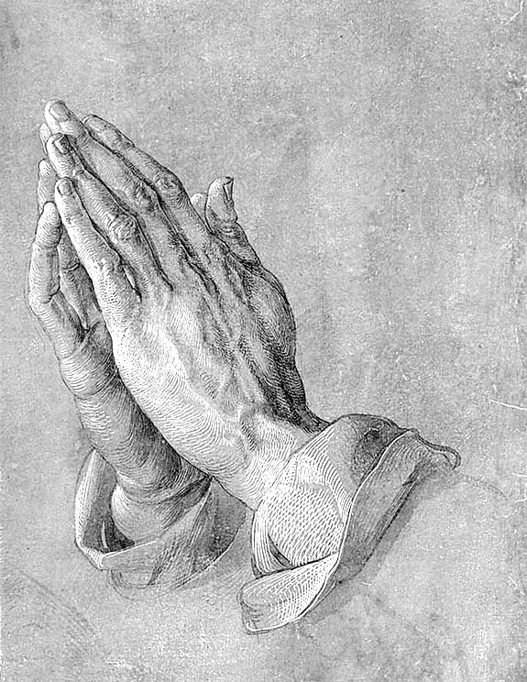
Healing Hands: 1980, Tulsa USA, Free standing statue

Seventeenth Sunday after Trinity
Proper 21 Pew sheet

Welcome to Saint John’s especially all who are visiting today!
An audio loop system is in operation for those with hearing aids.
Those baptised in the name of the Holy Trinity and are communicant members of their own church are welcome to receive the sacrament of Holy Communion according to conscience.

Today: Sunday 26th September 2021
9.00am Holy Communion (Order 1 page 180)
10.00am Sung Eucharist
6:30 pm Choral Evensong

Hymns: 537, 643, 37
Collect One

Lord, we pray thee
that thy grace may always prevent and follow us,
and make us continually to be given to all good works;
through Jesus Christ our Lord. Amen

Collect Two
Almighty God,
you have made us for yourself,
and our hearts are restless till they find their rest in you:
Teach us to offer ourselves to your service,
that here we may have your peace,
and in the world to come may see you face to face;
through Jesus Christ our Lord. Amen
First Reading Esther 7: 1-6, 9-10, 9: 20-22
71So the king and Haman went in to feast with Queen Esther. 2On the second day, as they were drinking wine, the king again said to Esther, ‘What is your petition, Queen Esther? It shall be granted you. And what is your request? Even to the half of my kingdom, it shall be fulfilled.’ 3Then Queen Esther answered, ‘If I have won your favour, O king, and if it pleases the king, let my life be given me—that is my petition—and the lives of my people—that is my request. 4For we have been sold, I and my people, to be destroyed, to be killed, and to be annihilated. If we had been sold merely as slaves, men and women, I would have held my peace; but no enemy can compensate for this damage to the king.’* 5Then King Ahasuerus said to Queen Esther, ‘Who is he, and where is he, who has presumed to do this?’ 6Esther said, ‘A foe and enemy, this wicked Haman!’ Then Haman was terrified before the king and the queen. 9Then Harbona, one of the eunuchs in attendance on the king, said, ‘Look, the very gallows that Haman has prepared for Mordecai, whose word saved the king, stands at Haman’s house, fifty cubits high.’ And the king said, ‘Hang him on that.’ 10So they hanged Haman on the gallows that he had prepared for Mordecai. Then the anger of the king abated.
20 Mordecai recorded these things, and sent letters to all the Jews who were in all the provinces of King Ahasuerus, both near and far, 21enjoining them that they should keep the fourteenth day of the month Adar and also the fifteenth day of the same month, year by year, 22as the days on which the Jews gained relief from their enemies, and as the month that had been turned for them from sorrow into gladness and from mourning into a holiday; that they should make them days of feasting and gladness, days for sending gifts of food to one another and presents to the poor.
This is the Word of the Lord. Thanks be to God

James 5: 13-20
Are any among you suffering? They should pray. Are any cheerful? They should sing songs of praise. ¹⁴Are any among you sick? They should call for the elders of the church and have them pray over them, anointing them with oil in the name of the Lord. ¹⁵The prayer of faith will save the sick, and the Lord will raise them up; and anyone who has committed sins will be forgiven. ¹⁶Therefore confess your sins to one another, and pray for one another, so that you may be healed. The prayer of the righteous is powerful and effective. ¹⁷Elijah was a human being like us, and he prayed fervently that it might not rain, and for three years and six months it did not rain on the earth. ¹⁸Then he prayed again, and the heaven gave rain and the earth yielded its harvest.
19 My brothers and sisters,* if anyone among you wanders from the truth and is brought back by another, ²⁰you should know that whoever brings back a sinner from wandering will save the sinner’s* soul from death and will cover a multitude of sins.

Gospel Mark 9: 38-50
38 John said to him, ‘Teacher, we saw someone casting out demons in your name, and we tried to stop him, because he was not following us.’ ³⁹But Jesus said, ‘Do not stop him; for no one who does a deed of power in my name will be able soon afterwards to speak evil of me. ⁴⁰Whoever is not against us is for us. ⁴¹For truly I tell you, whoever gives you a cup of water to drink because you bear the name of Christ will by no means lose the reward.
42 ‘If any of you put a stumbling-block before one of these little ones who believe in me, it would be better for you if a great millstone were hung around your neck and you were thrown into the sea. ⁴³If your hand causes you to stumble, cut it off; it is better for you to enter life maimed than to have two hands and to go to hell,* to the unquenchable fire. ⁴⁵And if your foot causes you to stumble, cut it off; it is better for you to enter life lame than to have two feet 49 ‘For everyone will be salted with fire. ⁵⁰Salt is good; but if salt has lost its saltiness, how can you season it? Have salt in yourselves, and be at peace with one another.’

This is the Gospel of the Lord

Praise to you, Lord Jesus Christ.

Psalm 124 Nisi quia Dominus Pg 744 BCP 2004
1,2 If the Lord himself had not been on our side,
now may | Isra∙el | say; ||
If the Lord had not been on our side,
when | enemies ∙ rose | up a|gainst us;
3 Then would they have | swallowed ∙ us a|live ||
when their | anger | burned a|gainst us;
4 Then would the waters have overwhelmed us
and the torrent gone | over ∙our | soul ; ||
over our soul would have | swept the | raging | waters.
5 But blessèd | be the | Lord ||
who has not given us over to be a | prey | for their | teeth.
6 Our soul has escaped
as a bird from the | snare ∙ of the | fowler; ||
the snare is | broken ∙ and | we are ∙ de|livered.
7 Our help is in the | name ∙ of the | Lord, ||
who has | made | heaven ∙ and | earth.
Glory to the Father and | to the | Son ||
and | to the | Holy | Spirit;
as it was in the be|ginning, is | now ||
and shall be for | ever. | A|men.

Post Communion Prayer
God our guide,
you feed us with bread from heaven
as you fed your people Israel.
May we who have been inwardly nourished
be ready to follow you
all the days of our pilgrimage on earth,
until we come to your kingdom in heaven.
This we ask in the name of Jesus Christ our Lord. Amen.

Summary of Readings
Esther 7:1-6, 9-10; 9:20-22: The king asks Esther what he can do for her, and she asks him to deliver her people from Haman’s plot. The king orders that Haman be impaled upon the stake he had made for Mordecai. Then Mordecai writes to all the Jewish people instructing them to always remember the days of their deliverance.
Psalm 124: A celebration of God’s help for God’s people, remembering how, when their enemies sought to destroy them, God helped his people to escape.
James 5:13-20: Those who suffer should pray, and those who are sick should call on the elders of the church to pray for them and anoint them with oil, because the prayers of righteous people are effective. Also, we should turn one another back whenever we stray from the truth.
Mark 9:38-50: Jesus tells his disciples not to stop a person who is casting out demons in Jesus’ name, and Jesus tells them to let him be, adding that whoever is not against him is for him. Then he teaches that anyone who gives one of Jesus’ disciples water will be rewarded, but those who cause little ones to stumble will be cursed. Anything that causes us to sin must be thrown away, and we must “maintain our salt” and keep peace with each other.
Services this week
Wednesday 29th September
7.30pm Zoom Compline Spiritual refreshment and reflection mid-week. Passcodes for Zoom will be emailed to all parishioners.
Thursday 30th September St Michael tr Eucharist 10.30am with prayer for those in need
A cup of tea/coffee is now available after this service.
Next Sunday 3rd October: Trinity 18 Proper 22
9.00 a.m. Eucharist
10.30 a.m. Harvest Sunday First

Harvest donations will be given to the South Belfast Foodbank. Please bring along to church on Sunday 3rd October. Thank you for your support.

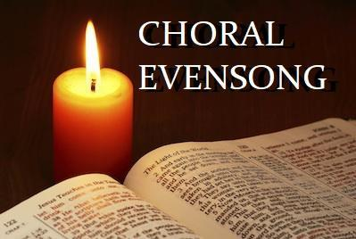
CHORAL EVENSONG for Michaelmas
Sunday 26th September 2021 at 6:30pm
Ancient wisdom Beautiful music Quietness & Reflection

Notices:
- Welcome to all our visitors. If you need assistance with anything, please ask one of the churchwardens or stewards
- Under GDPR guidance we need to tell you that we will be recording the service and/or livestreaming today. The cameras will point towards the nave altar and pulpit and only on occasion, towards the entrance doors. Those coming to and from the side areas and exiting will be in the camera view for a short time.
A reminder about some of our in-church worship protocols:
- Please remain in your seat that has been assigned to you unless it’s absolutely necessary to move out of it.
- A one way system remains in place in church as does mandatory handwashing at the cleansing stations on entry and exit. Masks are also worn during worship, on entry and exit and during singing. This keeps us safer and by doing this we look after our neighbour who may be more vulnerable than us.
- Remember to complete the Track & Trace page.
- Observe two metres spacing on the way in and out of church and inside church.
- If you display any of Covid19 related symptoms you should not come to church. Please observe government testing guidelines and isolation requirements.
- If you’re gathering outside please follow government guidance.

Citations from the Revised Common Lectionary, used and adapted for use in the Church of Ireland with permission, copyrighted © 1992. Consultation on Common Texts.

CCLI licence No. 2594164
St John’s Malone Charities Registration Number NIC101984

The Parish Secretary can be contacted on any administrative matters, or for information about organisations connected with St John’s (90667861) e-mail.secstjohns@btconnect.com

The Rector, Rev Canon Stephen Fielding can be contacted on pastoral matters (90666644)
e-mail malone@connor.anglican.org

Please PRINT your name and the names of any accompanying you today and supply a phone number to enable tracking and tracing. If you become ill with any symptoms of Covid19 and are subsequently tested positive, please contact the Rector as soon as possible and follow government guidelines. Deposit this sheet in the box in the porch on the way out. Thank you.
NAME: PHONE:
NAME:
NAME:
NAME:
NAME:
NAME:
NAME:
PEW NUMBER(S) (FOUND AT THE PEW END):
DATE:

Note: Please leave directly from your pew in the church through the north porch as directed by the stewards whilst maintaining 2m distancing.
You may wish to tear off this page when completed and take this booklet away with you.

